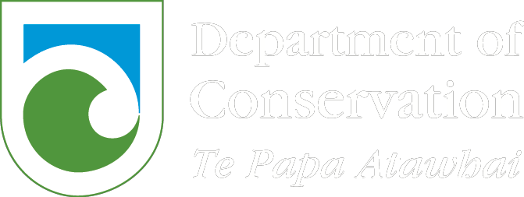 Application Form
Mining – Minimum Impact Activities

We recommend that you contact the Hokitika Permissions team to discuss the application prior to completing the application forms:
Permissions
Private Bag 701
Hokitika 7842
Email: permissionshokitika@doc.govt.nz
Please provide all information requested in as much detail as possible. Applicants will be advised if further information is required before this application can be processed by the Department. Please attach all required information and label according to the relevant section.
Once you have filled in your application form, please ensure you have completed the checklist on page 3 to ensure that all components of your application are complete. This will help prevent any possibly delays in the processing of your application.

Please tick
Have you read the section regarding the liability of the applicant for payment of fees?
Have you signed your application?

All efforts in putting together a detailed application are greatly appreciated and will allow the Department to effectively and efficiently process your application.

A. Applicant Details

Applicant Name
(full name of registered company or individual)

Legal Status of
applicant (tick)
Registered
Company

Individual

Trust

Incorporated
Society

Other (please specify full details)

Please supply the company, trust or incorporated society registration number:

If an individual please supply your date of birth (this is a unique identifier for you):

Trading Name
(if different from Applicant name)

Postal Address

Street Address (if different from
Postal Address)

Registered Office of Company or
Incorporated Society (if applicable)

Website
Phone

Contact Person and role

Cell Phone

Phone

Email

Alternative Contact Person and role

Email

Phone

Cell Phone

B. Crown Minerals Act Permit Details

You must hold a permit under the Crown Minerals Act to apply for consent for minimum impact activities on public conservation land, this cannot be granted until a permit has been granted by NZ Petroleum & Minerals.

Permit/Application Number | Permit type (Mining/Exploration/Prospecting) | Permit Area km

C. Application requirements and information

Please attach a detailed application including all the requested information, and label according to the numbered section below. Please complete the checklist to ensure all relevant details have been provided in your application.

- C1: Copy of Crown Minerals Act Permit attached (if granted).
C2: Clear map/plan of application area attached.
C3: Proposed activities attached.
C4: Outline of consultation undertaken with whanau/hapu/iwi.

Area sought for consent (include plan if required to define area) |  | km²/ha
Description of area, location and land classification

D. Fees

Processing Fee:

The processing fee will be $500 plus GST ($575 including GST) for straightforward applications, and $850 plus GST ($977.50 including GST) for complex applications.
Your application should be processed within 10 working days of receipt for straightforward applications and 22 working days for complex applications.

Terms and Conditions for an Account with the Department of Conservation:

No

Yes
Have you ever held an account with the Department before? (Please tick)
If yes, under what name?

- I/We agree that the Department of Conservation can provide my details to the Department’s Credit Checking Agency to enable it to conduct a full credit check.

- I/We agree that any change which affects the trading address, legal entity, structure of management or control of the applicant’s company (as detailed in this application) will be notified in writing to the Department of Conservation within 7 days of that change becoming effective.

- I/We agree to notify the Department of Conservation of any disputed charges within 14 days of the date of the invoice.

- I/We agree to fully pay the Department of Conservation for any invoice received on or before the due date.

- I/We agree to pay all costs incurred (including interest, legal costs and debt recovery fees) to recover any money owing on this account.

- I/We agree that the credit account provided by the Department of Conservation may be withdrawn by the Department of Conservation, if any terms and conditions of the credit account are not met.

- I/We agree that the Department of Conservation can provide my details to the Department’s Debt Collection Agency in the event of non-payment of payable fees.

Declaration

I certify that the information provided on this application form and all attached additional forms and information is to the best of my knowledge true and correct.

Note: The Minister can vary any minimum impact activities granted if the information given in this application contains inaccuracies.

Signature (Applicant): |  | Date:
Signature (Witness): |  | Date:
Witness Name:
Witness Address:

This application is made pursuant to Section 59 of the Crown Minerals Act 1991.

Applicants should familiarise themselves with the relevant provisions of the Conservation Act 1987 and the Crown Minerals Act 1991.

The purpose of collecting this information is to enable the Department to process your application. The
Department will not use this information for any reason not related to that purpose.

Applicants should be aware that provisions of the Official Information Act might require that some or all information in this application be publicly released.

For Departmental use
Credit check undertaken?
Comments:

Signed |  | Name
Approved (Tier 4 manager or above) |  | Name

