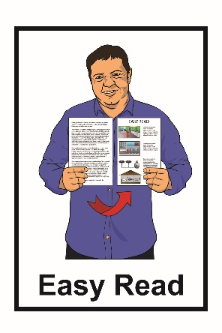

Caring for Aotearoa
New Zealand

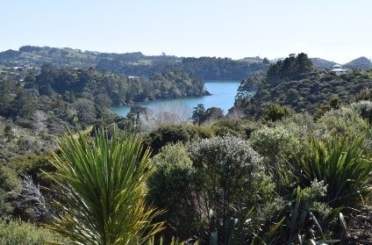
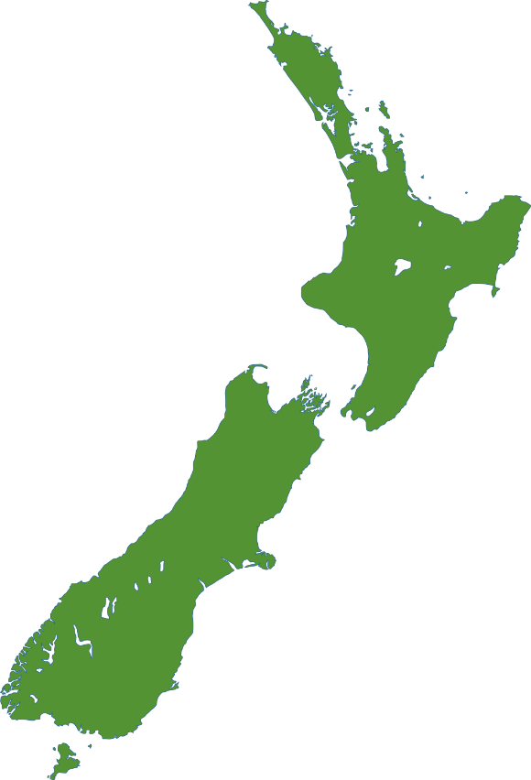

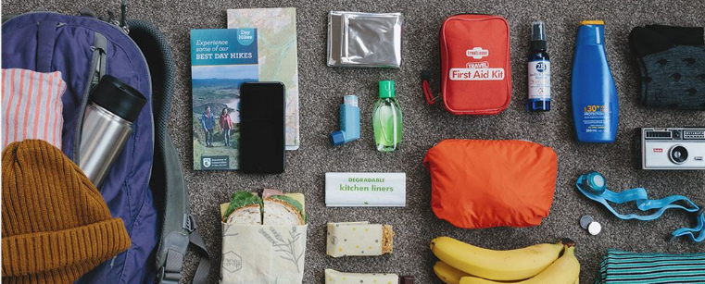

Department of Conservation

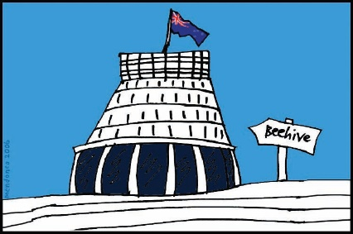

The Department of Conservation is a government agency in New Zealand.

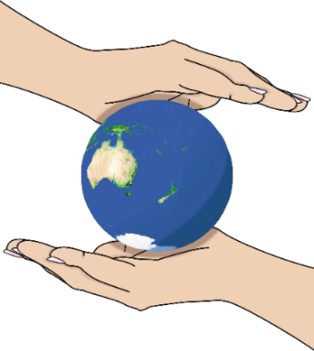
Conservation means protecting the natural world around us.

The Department of Conservation is in charge of protecting our:

- natural land

- important places.

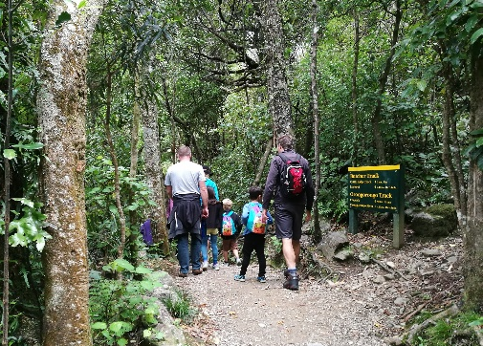
This document is about how you can also care for the places that the Department of Conservation looks after.
share the same culture or values.
Protect nature

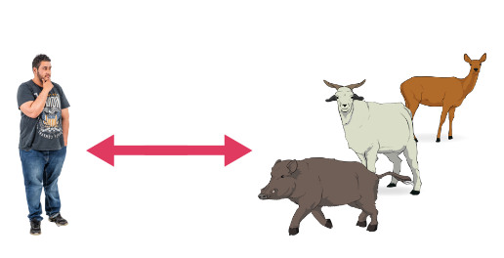
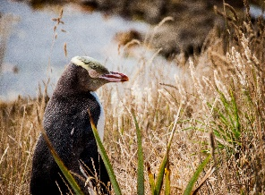

It is important that you:

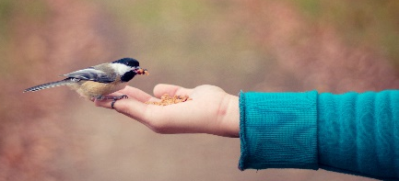
- keep a safe distance away from any wildlife you see

- do not feed any of the wildlife.
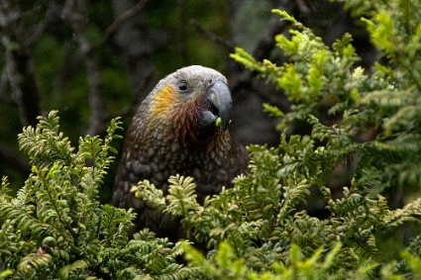
Wildlife means animals such as:

- birds like the keas and kiwis

- reptiles like tuatara

- sea animals like seals.

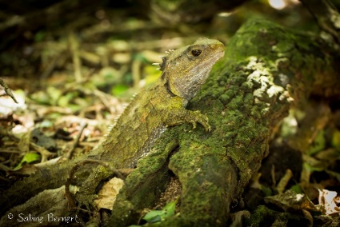

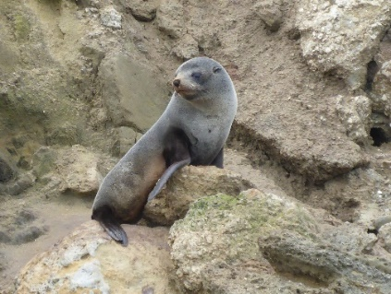

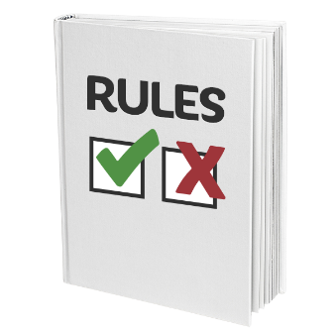
Make sure you follow any rules you see on signs.

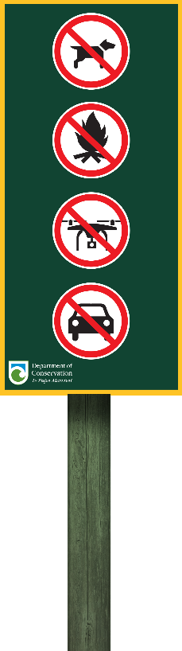
Some rules you might see on signs are:

- no dogs

- no lighting fires

- no flying drones

- no driving:

  - cars

  - trucks

  - motorbikes.

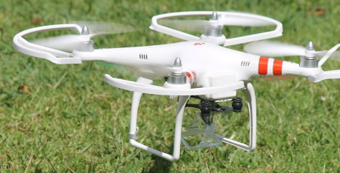

A drone is like a robot that a person can fly using a remote control.

Be prepared

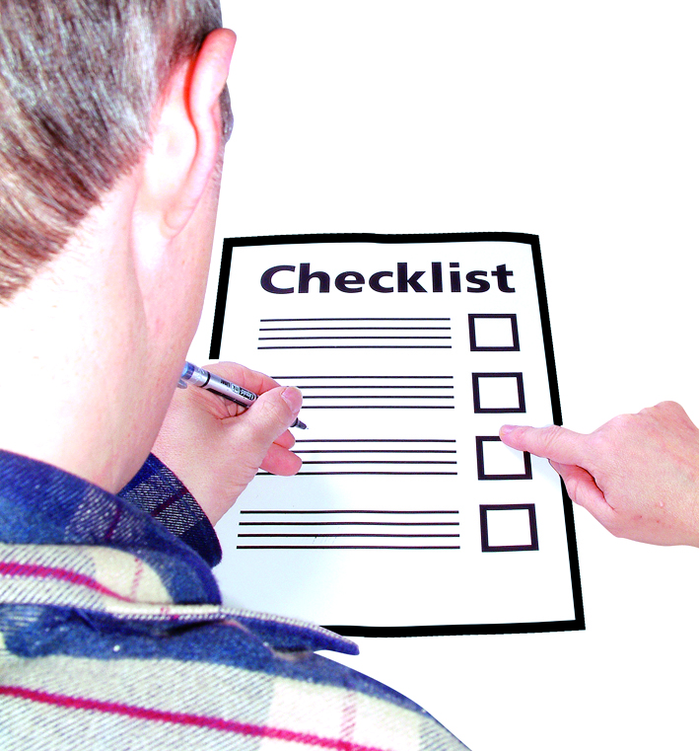
Stay safe while on your trip by following the Land Safety Code.

The Land Safety Code is made up of 5 important rules to help you stay safe while on your trip.

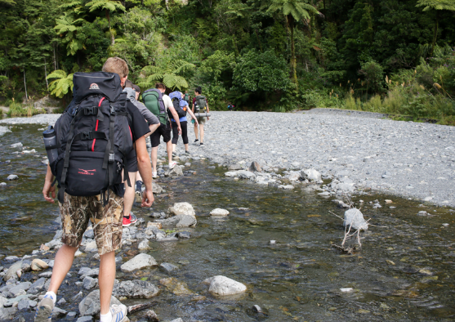
- Choose a day trip or overnight trip that is right for you.

You should:

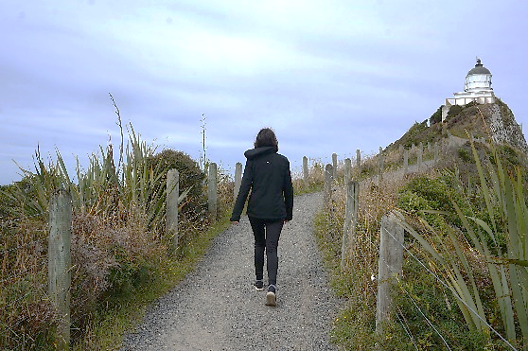
- learn about the place you are planning to visit

- make sure you have the skills to do the trip such as being able to walk a long way or up hills.
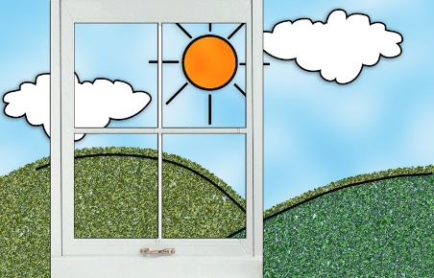
- Check that the weather is good for your trip

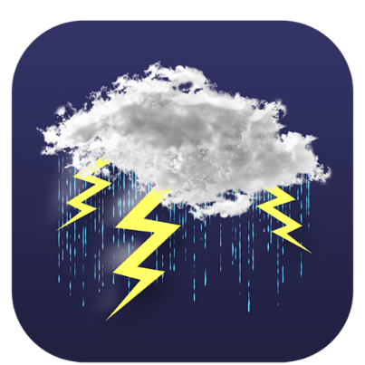
The weather can change fast.

You may need to change if your plans if the weather is not good for your trip.

- Pack a bag to take on your trip.

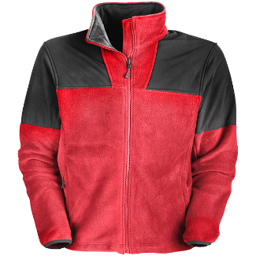
The bag should have things like:

- warm clothes
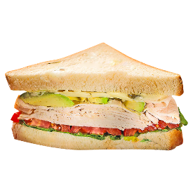
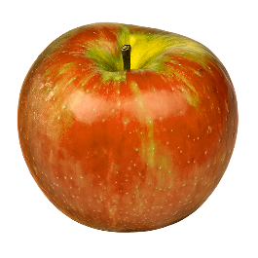
- extra food

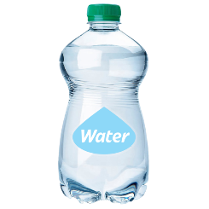
- water.

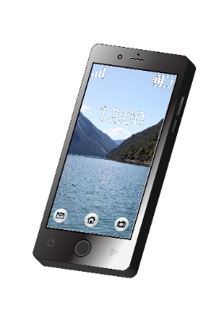
- Tell your family or friends about the trip you have planned.
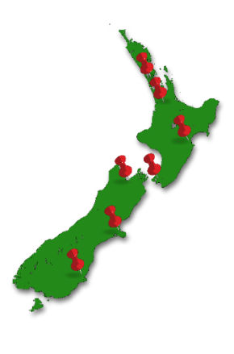

It is a good idea tell them:

- where you are going

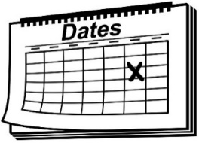
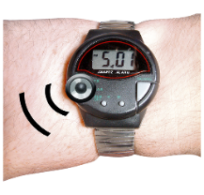
- who you are going with

- what time you plan to get back from your trip
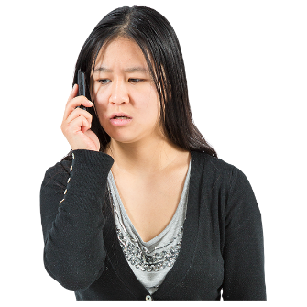
- to ring 111 if you do not come back from your trip.

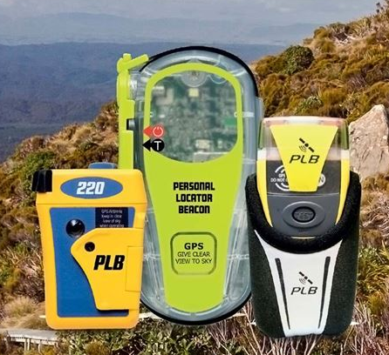
You may want to take a distress beacon.

A distress beacon is an electronic device that you can use to help rescue workers find you if you are lost or hurt.
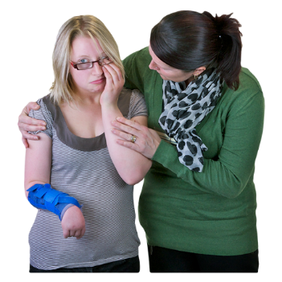
- Take care of:

- yourself

- each other.

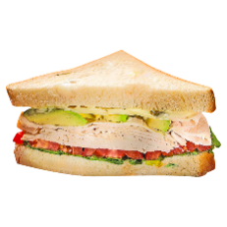
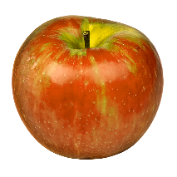
This means that while you are on your trip you should:

- eat food

- drink water

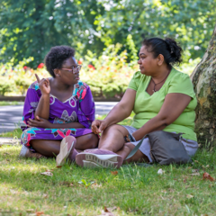
- take breaks to rest

- stay with your group

- make decisions together.

Keep New Zealand clean

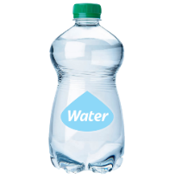
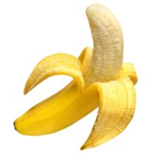

Take all of your rubbish with you.

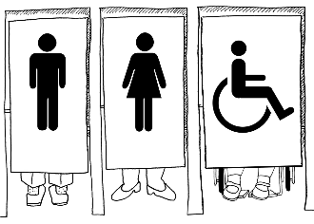
Use the toilets if there are any.

Show respect

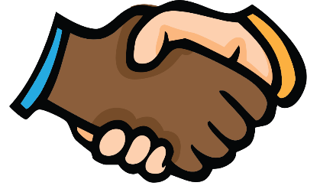
Respect means treating other people the way you would like to be treated.

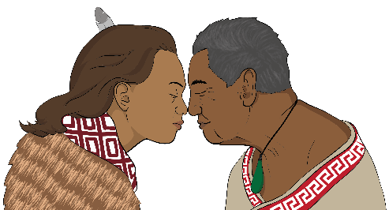
It is important that you show respect to all:

- people

- cultures.

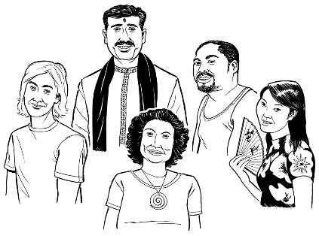

Cultures are ways of doing things because of:
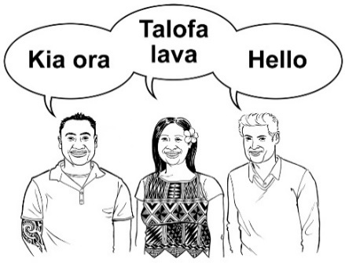
- groups you are part of
- the place you or your family come from
- what you believe.
Where to find more information

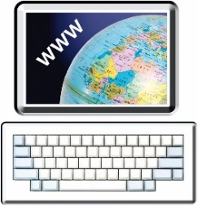
You can find more information about the Department of Conservation on their website:

https://www.doc.govt.nz/

You can also:

Email: enquiries@doc.govt.nz

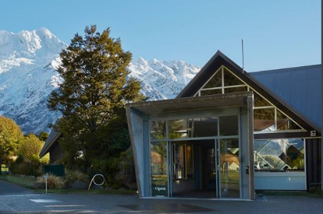
You can find a list of all the Department of Conservation visitor centres around New Zealand at this website:
https://www.doc.govt.nz/footer-links/contact-us/visitor-centres/
This information has been provided by the Department of Conservation.

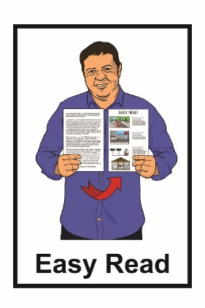
It has been translated into Easy Read by the Make It Easy service of People First New Zealand Inc. Ngā Tāngata Tuatahi.

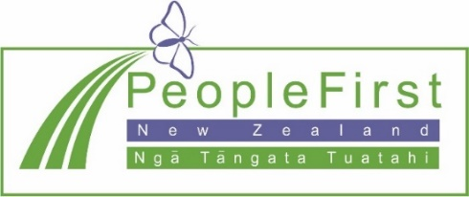
The ideas in this document are not the ideas of People First New Zealand Inc. Ngā Tāngata Tuatahi.

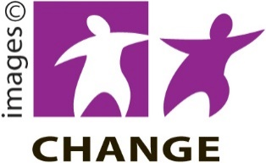
Make It Easy uses images from:
- Changepeople.org

- Photosymbols.com

- Sam Corliss.

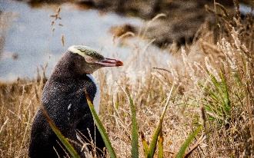
Thank you to these people for their permission to use their images:
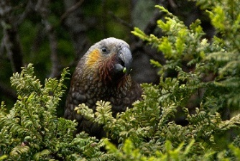
- Martyn de Jong – image of yellow eye penguin

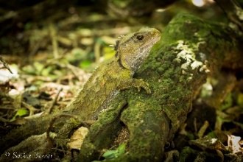
- Tomas Sobek – image of a kea

- Sabine Bernet – image of a tuatara
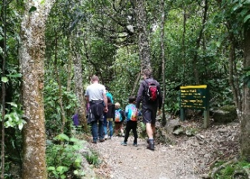
- Benhi Dixon – image of family walking the Orongrongo track.

Other images provided by Department of Conservation.

All images used in this Easy Read document are subject to copyright rules and cannot be used without permission.

Published August 2021.

